ViewModel

📝Definition
# Source: AI Source: Provided by: [Data Path: Persons Table -> ID Column: 1, Name_En Column: Motasem Essam] -> From: [ChatGPT] on [1/23/2026]
The ViewModel is a core component of the MVVM (Model-View-ViewModel) pattern. It acts as an intermediary between the View and the Model, holding the UI state, data, and commands while keeping the business logic separate.
👉 Think of the ViewModel as the translator: it prepares Model data for the View and handles user actions without touching the UI directly.

🔑 Responsibilities of ViewModel
# Source: AI Source: Provided by: [Data Path: Persons Table -> ID Column: 1, Name_En Column: Motasem Essam] -> From: [ChatGPT] on [1/23/2026]
- Expose Model data in a form the View can consume
- Hold UI state (e.g., selected items, visibility)
- Handle commands or actions triggered by the View
- Keep no reference to the UI (decoupled from View)
- Facilitate data binding between Model and View

🧱 Example: ViewModel in MVVM (JavaScript + Vue.js style)
# Source: AI Source: Provided by: [Data Path: Persons Table -> ID Column: 1, Name_En Column: Motasem Essam] -> From: [ChatGPT] on [1/23/2026]
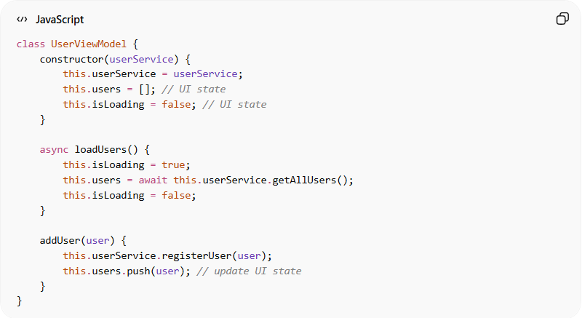
class UserViewModel {
constructor(userService) {
this.userService = userService;
this.users = []; // UI state
this.isLoading = false; // UI state
}

async loadUsers() {
this.isLoading = true;
this.users = await this.userService.getAllUsers();
this.isLoading = false;
}

addUser(user) {
this.userService.registerUser(user);
this.users.push(user); // update UI state
}
}
👉 Here:
- UserViewModel prepares data for the View
- Holds UI state (users, isLoading)
- Handles commands (loadUsers, addUser)
- Does not manipulate the UI directly

❌ Bad Example (ViewModel Doing Too Much)
# Source: AI Source: Provided by: [Data Path: Persons Table -> ID Column: 1, Name_En Column: Motasem Essam] -> From: [ChatGPT] on [1/23/2026]
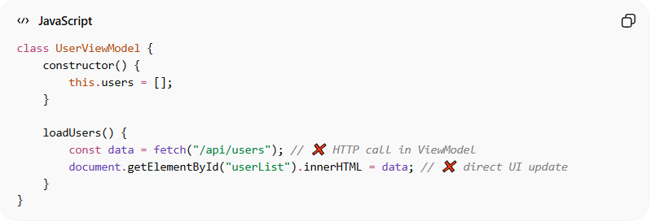
class UserViewModel {
constructor() {
this.users = [];
}

loadUsers() {
const data = fetch("/api/users"); // ❌ HTTP call in ViewModel
document.getElementById("userList").innerHTML = data; // ❌ direct UI update
}
}
Problems:
- ViewModel makes API calls directly
- Updates DOM/UI directly
- Breaks separation of concerns

✅ Good Example
# Source: AI Source: Provided by: [Data Path: Persons Table -> ID Column: 1, Name_En Column: Motasem Essam] -> From: [ChatGPT] on [1/23/2026]
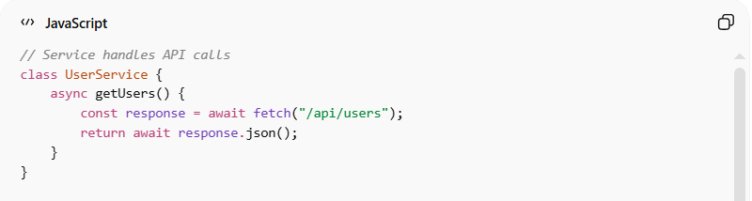
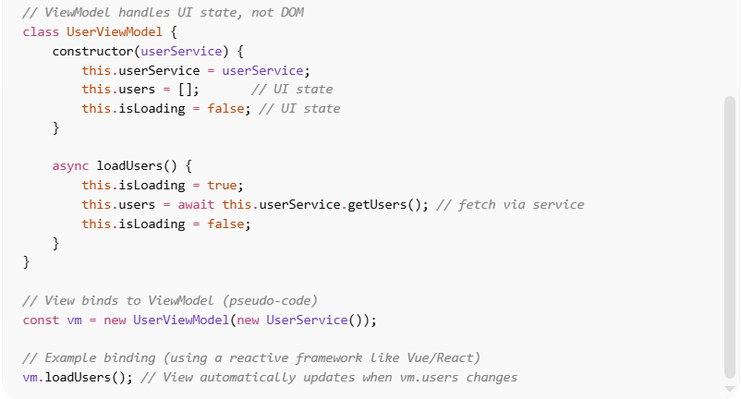
// Service handles API calls
class UserService {
async getUsers() {
const response = await fetch("/api/users");
return await response.json();
}
}

// ViewModel handles UI state, not DOM
class UserViewModel {
constructor(userService) {
this.userService = userService;
this.users = []; // UI state
this.isLoading = false; // UI state
}

async loadUsers() {
this.isLoading = true;
this.users = await this.userService.getUsers(); // fetch via service
this.isLoading = false;
}
}

// View binds to ViewModel (pseudo-code)
const vm = new UserViewModel(new UserService());

// Example binding (using a reactive framework like Vue/React)
vm.loadUsers(); // View automatically updates when vm.users changes
✅ Key Improvements
- API calls moved to Service → keeps ViewModel clean
- No direct DOM updates → reactive UI binds to vm.users
- Separation of concerns maintained → easier to test

✅ Good Practices
# Source: AI Source: Provided by: [Data Path: Persons Table -> ID Column: 1, Name_En Column: Motasem Essam] -> From: [ChatGPT] on [1/23/2026]
- ViewModel only calls Services to fetch data
- Exposes data and commands to the View
- Uses data binding for UI updates
- Keeps UI-independent logic in ViewModel

🔄 ViewModel in Different Patterns
# Source: AI Source: Provided by: [Data Path: Persons Table -> ID Column: 1, Name_En Column: Motasem Essam] -> From: [ChatGPT] on [1/23/2026]
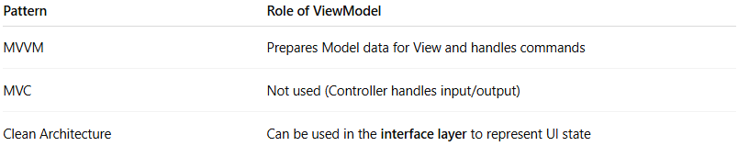
Pattern | Role of ViewModel
MVVM | Prepares Model data for View and handles commands
MVC | Not used (Controller handles input/output)
Clean Architecture | Can be used in the interface layer to represent UI state

💡 Key Idea
The ViewModel decouples the View from the Model, allowing the UI to stay reactive, testable, and maintainable.

🧩 ViewModel vs Controller

1️⃣ Controller
# Source: AI Source: Provided by: [Data Path: Persons Table -> ID Column: 1, Name_En Column: Motasem Essam] -> From: [ChatGPT] on [1/23/2026]
Where used: MVC (Model-View-Controller)
Purpose: Orchestrates input and flow between View and Model/Service.
Key points:
- Receives input from the View (user actions, forms, clicks).
- Calls Services or Models to perform business logic.
- Updates the View with results.
- Does not store UI state — only coordinates actions.
Example (Java MVC Controller):
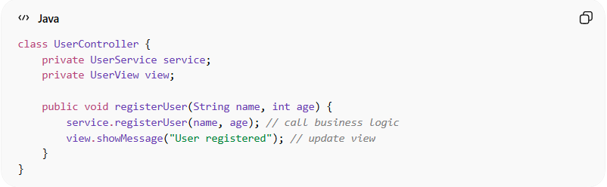
class UserController {
private UserService service;
private UserView view;

public void registerUser(String name, int age) {
service.registerUser(name, age); // call business logic
view.showMessage("User registered"); // update view
}
}
✅ Controller = traffic director. It receives input and forwards it.

2️⃣ ViewModel
# Source: AI Source: Provided by: [Data Path: Persons Table -> ID Column: 1, Name_En Column: Motasem Essam] -> From: [ChatGPT] on [1/23/2026]
Where used: MVVM (Model-View-ViewModel)
Purpose: Holds UI state, prepares data for the View, and exposes commands.
Key points:
- Holds observable UI state (e.g., selected items, loading indicators).
- Prepares Model data for display (formats, maps, filters).
- Exposes commands/actions the View can call.
- Does not reference the View directly — communicates via binding.
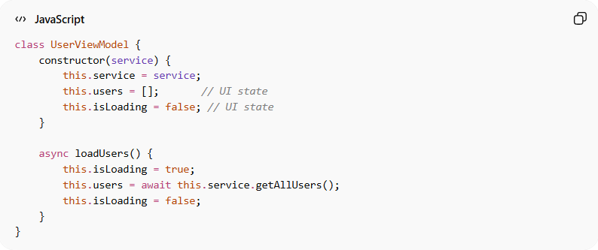
Example (JavaScript MVVM ViewModel):
class UserViewModel {
constructor(service) {
this.service = service;
this.users = []; // UI state
this.isLoading = false; // UI state
}

async loadUsers() {
this.isLoading = true;
this.users = await this.service.getAllUsers();
this.isLoading = false;
}
}
✅ ViewModel = UI state manager + data preparer.

3️⃣ Main Differences
# Source: AI Source: Provided by: [Data Path: Persons Table -> ID Column: 1, Name_En Column: Motasem Essam] -> From: [ChatGPT] on [1/23/2026]
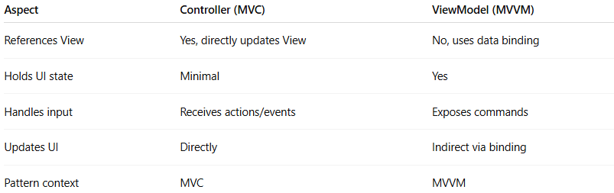
Aspect | Controller (MVC) | ViewModel (MVVM)
References View | Yes, directly updates View | No, uses data binding
Holds UI state | Minimal | Yes
Handles input | Receives actions/events | Exposes commands
Updates UI | Directly | Indirect via binding
Pattern context | MVC | MVVM

🔑 Key Insight
# Source: AI Source: Provided by: [Data Path: Persons Table -> ID Column: 1, Name_En Column: Motasem Essam] -> From: [ChatGPT] on [1/23/2026]
- Controller = coordinates actions between View and Service/Model.
- ViewModel = manages UI state and prepares data for the View.
- In small apps, they may look similar, but conceptually they serve different roles.

🧾 Summary
# Source: AI Source: Provided by: [Data Path: Persons Table -> ID Column: 1, Name_En Column: Motasem Essam] -> From: [ChatGPT] on [1/23/2026]
- Holds UI state
- Prepares Model data for the View
- Handles commands from the View
- Keeps business logic in Services
- Facilitates data binding

